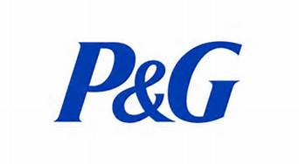
RELEASE AND WAIVER OF LIABILITY

I warrant and represent that I wish to voluntarily participate in the United Way P&G/ Gillette Golf Tournament, hosted by P&G/ Gillette. As a condition of my participation in the Event, I understand and agree as follows:

Acknowledgement and Acceptance of Risks

I understand and acknowledge and hereby do waive and release any and all rights, claims, and causes of action whatsoever I may have against the Sponsor or its affiliates or subsidiaries, or any of their agents, employees, officers or directors, for any matter, cause or thing whatsoever arising out of or in connection with my participation in the Event. I understand and acknowledge that the Event and/or the facility hosting the Event are not Sponsor-owned or Sponsor-managed, and that Sponsor disclaims all warranty and liability associated with the administration of the Event.

I understand that participation in the Event may have inherent dangers and may involve situations that could cause embarrassment or discomfort and that no representation or warranty of any kind has been made by Sponsor concerning the condition or the suitability of anything associated with the Event. I further understand that the Event may carry inherent risks to person or property and I knowingly assume all risks associated with such activities to the maximum extent permitted by law.

Activity at the Event

I understand and agree that I am solely responsible for my activities and conduct at the Event and agree that I will conduct myself in an appropriate manner at all times. I further agree that Sponsor is not responsible or liable for my actions related to the Event. I agree to follow all laws and regulations at the Event.

I understand and agree that this Release and Waiver of Liability shall be governed by the laws of the State of Ohio, United States of America (without regard to the conflicts provisions thereof).

I understand and agree to the terms above.

____________________________ ____________________________
Signature Name

____________________________
Printed Name

____________________________
Date

